Phase 1

Task 4

Create IAM user with AdminAccess policy

Task 5

Install Docker Desktop

Docker installed successfully.

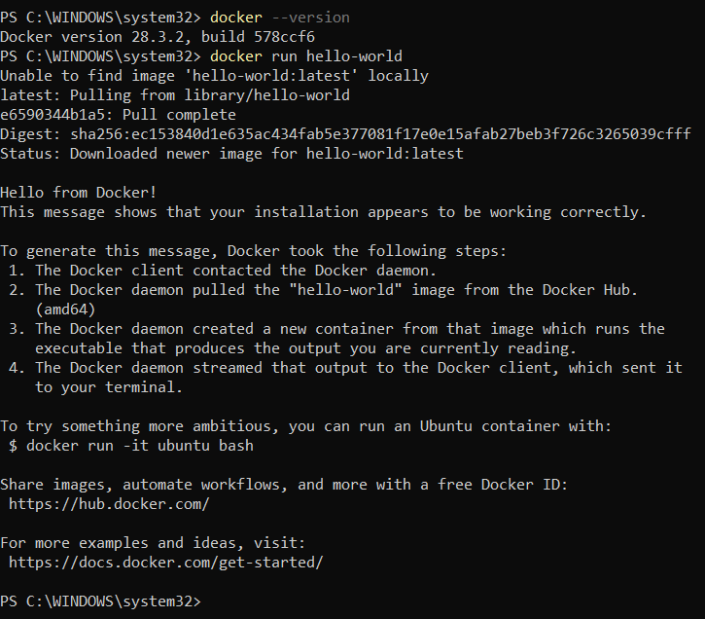

Task 7

Minikube installed successfully

Minikube runs successfully

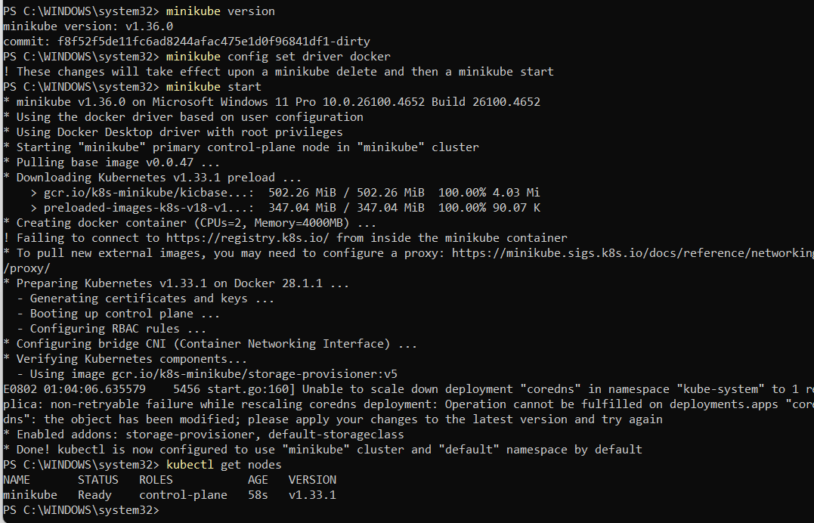

Task 9

Helm installed successfully



Phase 2

Task 1

Start a local Minikube cluster

task 17

Enable Ingress Controller on Minikube

Set Docker env to Minikube for image builds and Built a Test Image

Deploy a test pod and service to validate cluster. deployed a pod running the [**echoserver**](https://github.com/kubernetes/contrib/tree/master/echoserver), a lightweight test image that **echoes back request info**.

Phase 3

Task 25: *Serve the Lugx static site using an NGINX Docker container*  
(a.k.a. *Convert it into a containerized frontend application using Docker*)

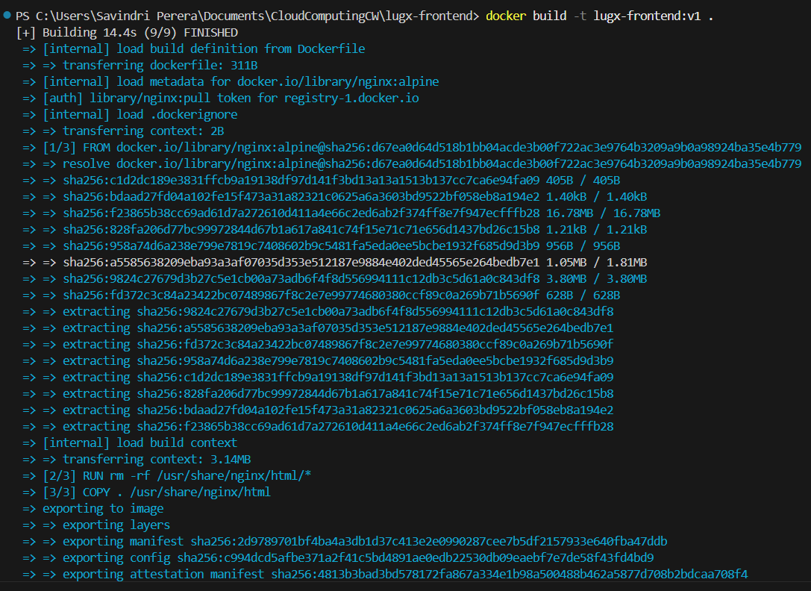

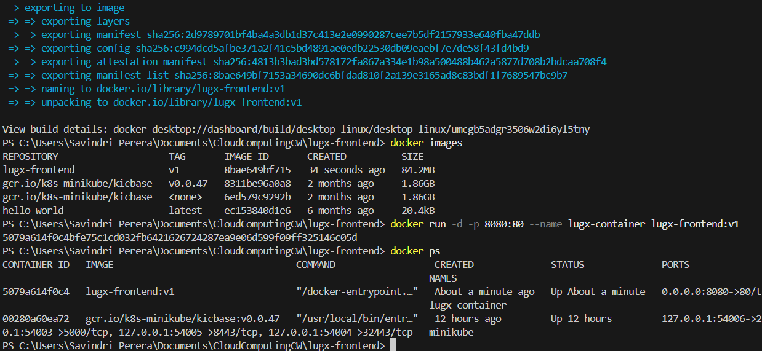

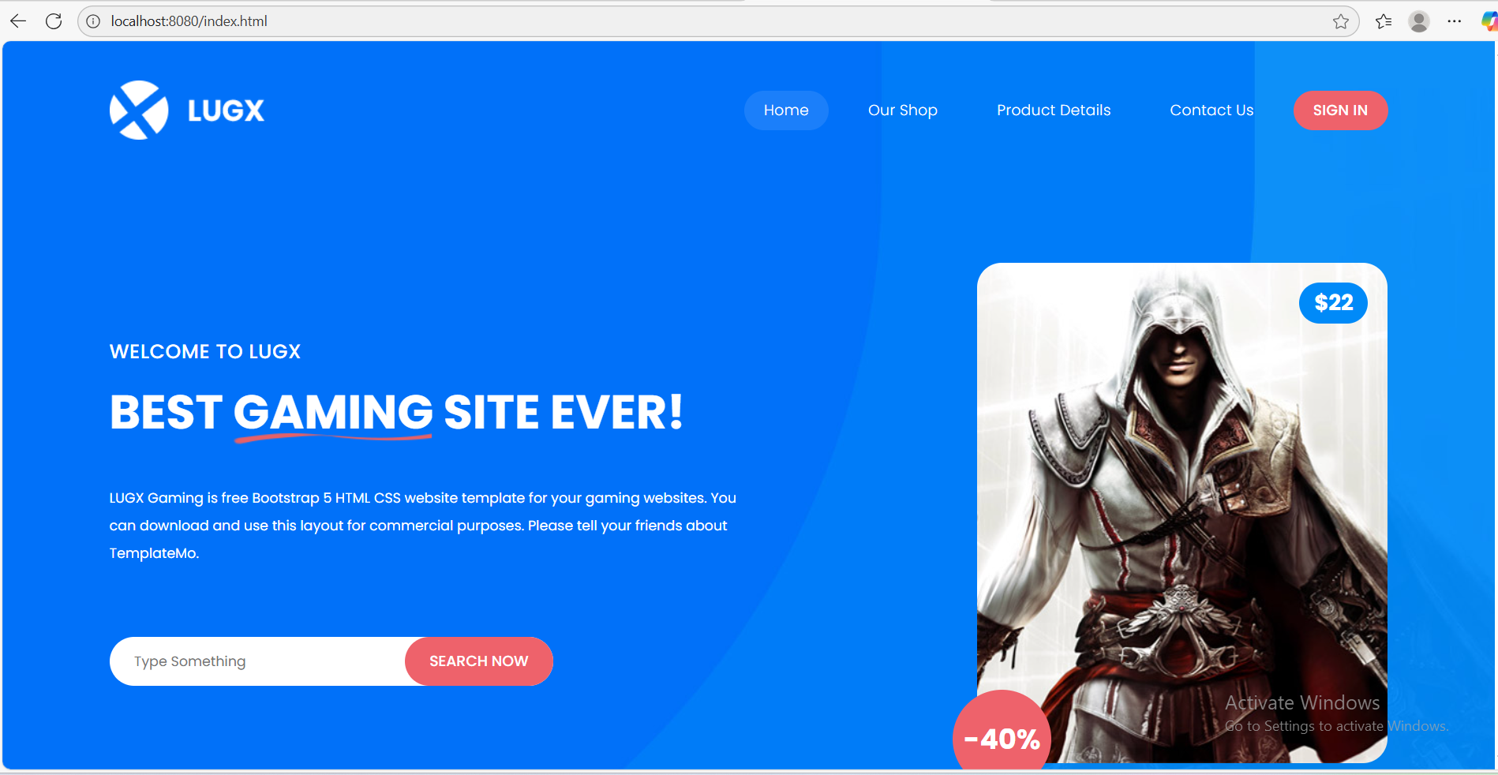

Task 28

Log frontend events to browser console

Log frontend events to dummy endpoint (using webhook.site)

Phase 4

Task 30

Task 31

Task 35

achieved a successful connection between Frontend JavaScript (running in the browser) and **Flask backend API on localhost:5000**, which writes analytics data to ClickHouse (via clickhouse-driver)

Task 36

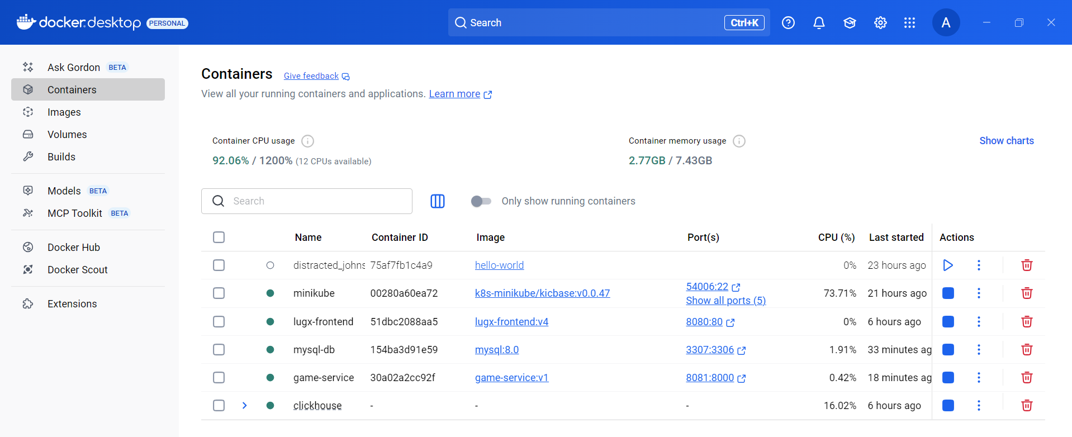

Health check

POST

Use **PowerShell-native syntax**

GET

browser

Postman

Get by id

MySQL

PUT

DELETE

Task 37

Task 37

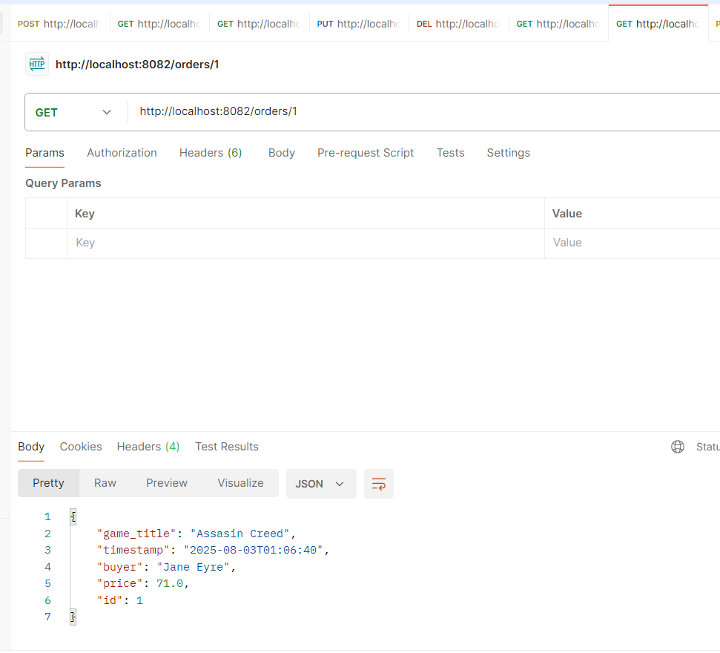

Task 38

